

The BEST Method
Biomechanically Efficient Shooting Technique

The USA Archery Coach Development Committee (CDC) wanted to find an easy to remember name for the fundamentals of shooting a bow that had no specific “ownership” attached to it. In other words, it is not the “American System”, “Korean System”, or any other “system” originating from a particular person or place. It is, in fact, the system that history has shown to be most effective. There are many ways to shoot a bow and arrow, but there is only one best way that provides a non-limiting path to high performance. This one way is founded on principles of biomechanics that, in essence, have existed and have been employed within archery for many years. From centuries past early archers were capable of accurately shooting arrows at distances of 300 -500 meters, with bows having draw weights of 150-200 pounds. Modern archers have achieved scores that not too many years ago would have seemed unattainable. How could either of these things have happened unless these archers were proficient at using their body structure in the most efficient manner? The study of biomechanics helps us understand how this can be done.

Biomechanics is the science that examines the internal and external forces acting on the human body and the effect produced by these forces.

Goals of Using Biomechanics

Archery coaches and team leaders are always looking for the best ways to improve the performance of their athletes. For a long time, in the United States, archers trained independently. They developed a wide range of shooting techniques that led to tournament success. Many of these archers were top competitors in international championships, winning medals at the Olympic Games and World Championships.

International teams, especially in South Korea, have centralized archery training. In their efforts to improve performance, they have scientifically studied every aspect of the archery shot process with the goal of improving biomechanical efficiency. They have found that shooting consistency and higher scores result from the application of this scientific knowledge to the shooting form of their athletes. The results of these efforts have been remarkable. In the recurve division, South Korean archers dominate international competition. South Korea is making rapid advancements in compound performance as well.

Members of USA Archery’s Coach’s Development Committee and other top US archery experts have done their own study of biomechanics as it applies to archery performance. USA Archery has created a series of teaching techniques and resources to enable coaches and athletes to make the most of their training time by focusing on methods that use the body’s structure and energy efficiently to improve performance.

The results of these efforts have been named the Biomechanically Efficient Shooting Technique or BEST method. The BEST method aims to improve an archer’s performance through specific shooting forms, equipment configurations, training methods and coaching techniques. In addition to improving scores, the BEST method reduces athlete fatigue and can help reduce the risk of injury.

Tools Used in Biomechanics:

The BEST method has been derived by careful study of the most successful archers in international competition combined with extensive scientific research into all aspects of the archery shot. Included study areas and methodologies include, Newtonian Mechanics, Motion Analysis Systems, High Speed Video, Normal Speed Video, Force Measurement Devices (Force Plates), Electromyography (EMG), Computer Video Analysis, Delayed Video Playback, Heart Rate Monitors, and Insole Systems. The result of these study efforts is a shooting form approach that maximizes the body’s strengths and minimizes the shot variables.

The Components of the Shot

The archery shot is not simply a set of static poses. It is a dynamic process that progresses through a series of components from beginning to completion. You may have heard of, or used, the “9 Steps to the 10 Ring” approach to defining the process of executing an archery shot. The new NASP materials and NAA Instructional materials will contain the “11 steps to archery success”. The book Total Archery by Kisik Lee has 12 steps to the shot process. The FITA Coaches Manual has 4 stages to the shot. Remember that these “step” explanations are offered to help simplify understanding and are mostly useful in teaching beginners because of the increased level of conscious mind involvement at that level. As an archer progresses, the shot becomes more of a single entity that flows through stages or phases, rather than a step process.

In the BEST method these “steps” are modified into 4 phases and several components. The number is not important as long as the correct concepts are included. To the casual viewer, the conventional archery shot and the BEST archery shot may look much the same. However there are important differences that improve the consistency, accuracy and repeatability of the BEST method approach.

The phases and components of the BEST method archery shot are:

I. The Foundation of the Shot
Stance
Body Position
Center of Gravity & Stability
The Bow Shoulder
The Draw Shoulder
The Bow arm
The String Hand
The Grip
- The Shot Set-up
Mindset
Pre-draw
Draw
Anchor
III. The Execution of the Shot
Transfer/Loading and Holding
Aiming and Expansion
Release
Follow-Through
IV. The Recovery
Relaxation and Feedback

Archers should develop a ritual for Nocking consistency: As the arrow is nocked, check for nock fit & tension with the string. Check the nocks for rotation and index the fletching consistently to insure clearance. As you nock the arrow, focus on the task. Pay attention to each step and listen for the “snap” sound to be sure the arrow nock is fully seated. Check also for correct clearance between the arrow nock and the string serving. The arrow should stay in place while the string is able to rotate freely in the nock grove.

I. The Foundation of the Shot

The foundation of the shot is the static alignment of the body and the equipment that leads to a stable shot platform. When the body is stable, the archer’s shots will be more consistent and less frustrating. The elements of the foundation of the shot include: the stance, including the foot position and leg alignment; the body position, including the orientation of the hips and rib cage; the archer’s center of gravity & maintaining stability; the position of the bow shoulder; the position of the draw shoulder; the position of the bow arm; and the archer’s hand position and grip on the bow handle are also all part of the foundation. As the foundation of a house sets the stage for what comes afterward, the foundation of a shot sets the stage for good shot performance.

The Stance begins with the placement of the feet. Beginning archers should stand at the shooting line with a square or slightly open stance. The toes of the archer’s shoes should be on a line towards the target or with the target side foot no more than 2” or 3” behind that line. A more open stance is acceptable for higher level archers who have found that the resulting twist of the torso increases archer stability in windy conditions.

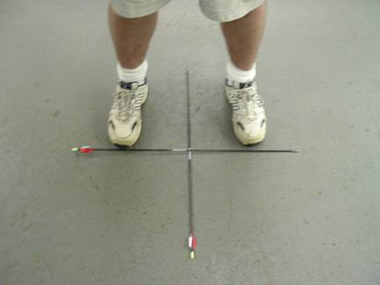

Square Stance

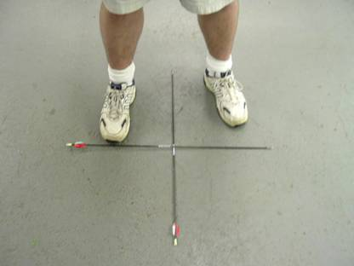

Slightly Open Stance

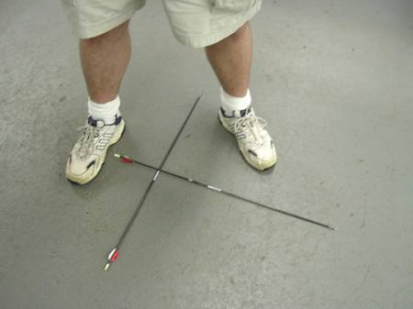

A more open stance is acceptable for higher level archers
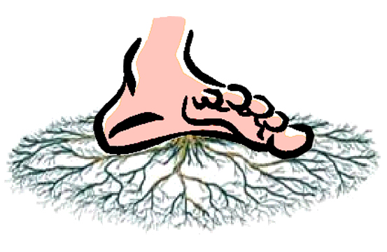
When standing at the shooting line, allow the feet to spread out both longer and wider. The archer should feel a sensation of sinking into the ground or spreading roots.

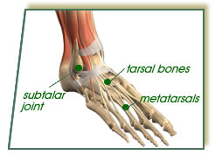
The leg position has the knees relaxed but not bent. Archers should work on building leg strength and core strength. Strong legs and torso muscles are the foundations of stability. Strengthening the legs should be a major focus in an archer’s physical training program.

An archer’s weight distribution on the feet should be about 70% on the balls of the feet where the body’s balance receptors are located. Keeping your weight forward improves your balance and can reduce the tendency of the body to rock while standing at the line. It may be helpful to wear a shoe with a slightly raised heel to help shift the weight forward. Avoid shoes with soft or rounded soles such as those found on typical running and cross-training shoes. These types of shoes separate the archer’s foot from the ground and reduce the stability of the shot platform.

The body position aligns the upper body with lower body. The shoulders, chest & ribs should be relaxed and moved down. The positioning of the ribs and shoulders should be straight down, with no “hunching” or slouching. The pelvis is rotated vertically with the lower part of the pelvis forward to tuck under the body. The goal is to create a “flat back” and avoid the deep curvature of the back that has been common in older US shooting technique. The head is held in a natural vertical position and is turned toward the target without tilting. The neck and shoulder muscles are relaxed

For stability, the center of gravity (COG) of the archer must be as low as possible. When you stand on the line, allow the body to relax downward. It is especially important to keep the ribs and shoulders down at all times during the shot. Chest compression (or keeping the ribs down) provides several biomechanical advantages to the archer. It prevents arching of the back and allows the back to relax. Chest compression aids body stability and improves the clearance between the chest and the string. Lowering the ribs improves the alignment and stability of the shoulders and promotes good overall balance.

The draw (rear) shoulder must be kept down as low as possible during the pre-draw, draw and throughout the shot. Raise the bow into position by moving the arms upward without raising the shoulders. The drawing hand and forearm should lie on a line even with or slightly below the line of the anchor point and should come to full draw as one unit. The alignment of the forces that hold the bow and string is very important. Avoid positioning the hands, elbows and shoulders in such a way as to create angles, rather than straight lines. The tip of the drawing elbow should be in line with the arrow at full draw when viewed both from the side and when viewed from behind.
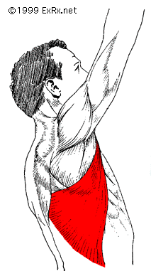
The bow (front) shoulder must be kept down also. Raise only the bow arm and bow, not the shoulder when bringing the bow up into pre-draw position. As you raise and extend the bow arm, feel as if you are reaching for the target. “Feel” as though you are raising the arm from underneath by activating the latisimus dorsi muscles seen in the illustration. Keep in mind that the elevation of the arm is performed by the deltoid muscle on top of the shoulder region, but when raising the bow arm the archer should focus less on the deltoid and more on engaging the muscles underneath the arm to promote stability and to help keep the shoulder low.

As you reach for the target look for the acromial notch (dip or groove) in the shoulder as a sign that you have found correct position and extension, as seen in the photo below.

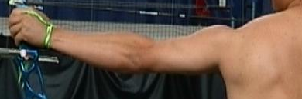

The Bow Shoulder

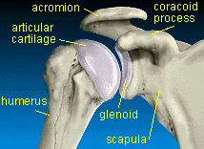
The key components of the shoulder are shown in the illustration to the left. The acromion is a bony extension of the scapula that rises above the shoulder joint. The coracoid process is another bony extension of the scapula that comes towards the front of the body. The articular cartilage is a protective and lubricative material on the top end of the humerus or upper arm bone. The glenoid fossa acts as a cushioning and lubricative material attached to the shoulder socket portion of the scapula. The scapula are attached to the rib cage with muscles that allow it to move up and down, left and right, as well as rotating clockwise and counterclockwise. The BEST method places a lot of attention on correct scapula position both during the draw and while at anchor.
articular
cartilage
acromion
coracoid
process
humerus
glenoid fossa
scapula

A good bow arm is strong and steady and does not move upon execution of the shot until after the arrow has cleared. The head of the humerus or upper arm bone must be rotated internally (clockwise for a right-handed archer) into position for proper alignment, stability and strength. This will also cause the bow elbow to rotate out (away form the arrow).

Note the position of the bow arm elbow rotated away from the arrow.

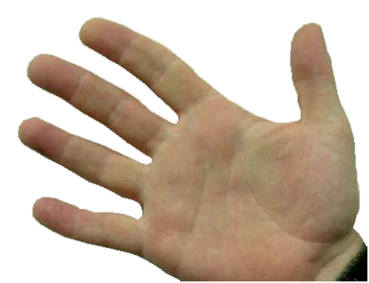
It is important to have consistent string hand placement and confirmation. As you grasp the string with your draw hand the string should be positioned just behind the first joint of the middle finger.

This string placement allows the archer to form a solid, deep hook with the draw hand. The deep hook enables the draw hand to relax and minimizes muscle stress. Keep back of string hand flat and vertical. As part of your shot routine, visually check the draw hand position on every shot for consistency. It is also important to verify the position of the draw fingers and the finger tab with respect to the nocking point. Even a small variation in finger position along the string can have a big impact on consistency.
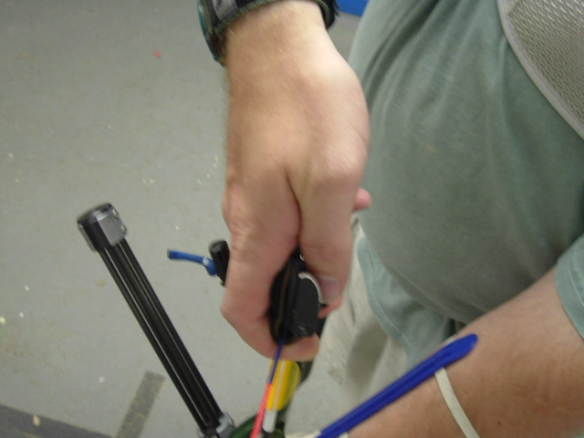
The Bow Hand
The bow hand placement can be facilitated by putting a modest amount of tension on the string as the bow hand is relaxed and placed into position.

This string tension will hold the position of the draw hand on the string and will set the bow handle into the bow hand.

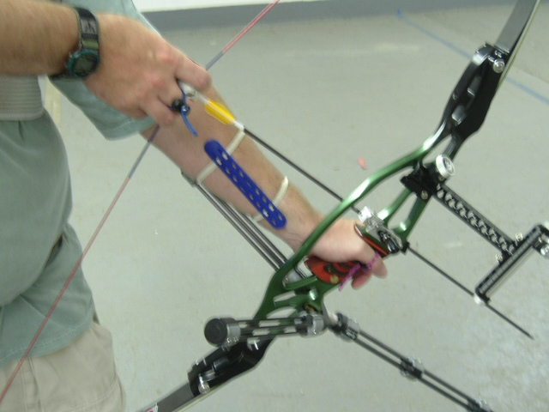

The bow hand should fit snuggly into the upper portion of the throat of the grip. The knuckles of the bow hand should be relaxed and positioned at a 45 degree angle to the bow riser. The thumb should be pointed toward target. A wrist or finger sling should be used to restrain the bow from flying forward out of the hand during the release. At no time should the bow handle be grasped.

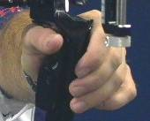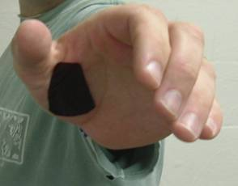

The Grip & Grip Pressure

The direction, distribution and amount of pressure on the bow hand must be consistent and “natural.” At no time should the bow handle contact the bow hand to the outside of the “life line’.
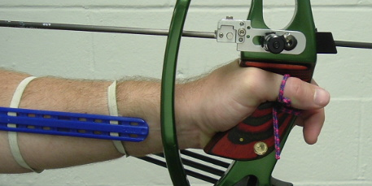
A moderately low wrist position is stronger and more forgiving when shooting lots of arrows. This wrist position also directs the force of the bow directly through the bones and minimizes the fatigue of holding the wrist in an unnatural position. However, it is common for elite archers to customize their bow grip, often making it moderately high.

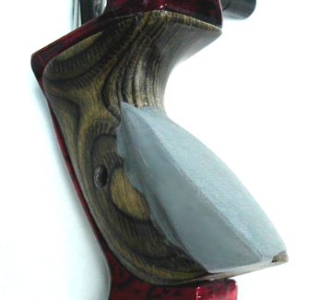
A customized grip that aides in getting consistent hand placement can be very valuable and if properly designed can compensate for the normally weaker low wrist position. The grip modification shown below will benefit the biomechanics of the bow arm, improve bow hand stability and compensate for bow hand torque. Properly designed, the modified grip will help the archer develop the correct hand position and consistent “feel.” The bow hand position must be natural and never forced. The grip can be modified by adding epoxy putty to the plastic grip and shaping it with a rasp.

To summarize, the foundation of the shot focuses on arranging the body and its component parts into the strongest and most stable configuration possible prior to the application of internal and external forces. This is accomplished by proper “load bearing” alignment that reduces fatigue and the potential for injury. Establishing stability will reduce movement during the shot and increase the archer’s sense of confidence. The foundation must, in every instance, be established precisely the same way every time to create consistency. The foundation also sets the tone for the shot and supports the shot, making it easier to execute and thus easier to duplicate. The design of this set of foundation positions is supported by carefully observed biomechanical and physical principles. It is the most efficient and effective way to perform an archery shot.

II. The Shot Set-Up

The archery shot is not simply a matter of mechanics. The mindset of the archer should also be as consistent as the shooting form. The right mindset promotes top performance. As you develop your shooting form, create the habit of establishing a mental program or mindset that is the same for practice and competition. The right mindset is process oriented rather than result oriented. Separate practice sessions utilizing relaxation exercises and controlled breathing will train the body to recognize and repeat the feeling of relaxation. When the time comes to compete, you will know how to calm your body. Placing a point of initiation in the shot sequence for getting your mindset will help you to shoot more consistently.

The next step in the process is the pre-draw. In this stage the archer check the position and pressure in the bow hand and the string hand. The direction, distribution and amount of pressure on the bow hand must be consistent and “natural.” It is recommended that the finger pressure on the draw hand at full draw be as follows:

Index finger: 20 – 20%
Middle finger: 50 – 60%
Ring finger: 15 – 20%

Check to see that the pressure on the foot is 60 – 70% on balls of feet. Avoid putting the weight on the heels of the foot.
The hip position is very critical for complete body stability. Tilt the pelvis forward at the bottom to flatten the back and keep the center of gravity of the body in line with the foot position. Avoid arching the back or having the buttocks stick out.
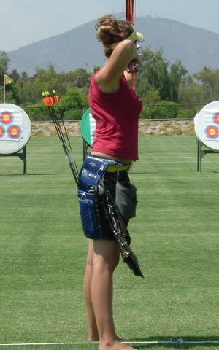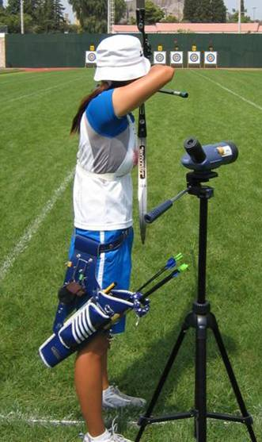
Elite American Back Elite Korean Back
(Note the straight line along the back).

Check for maximum stability. This requires lowering the body’s center of gravity as much as possible. The center (or core) of the body is located about 3 inches below the navel and about 2 inches to the inside. All power, force and control radiates from this central spot. Athletes should practice locating the core of the body and tightening the abdominal muscles to concentrate this core feeling. Pretend that there is a ball about the size of a orange inside your abdomen and pretend to squeeze it with your gut muscles (the key muscle involved is the transverse abdominus). In time, practice will strengthen your abdominal muscles and help you to find your core at the shooting line. The goal of the proper technique is to lower the body’s center of gravity (chi) to increase stability. The power in the “core” is equal to power needed to lift an object. Your body’s power comes from the “core”.

Chest compression, or keeping the ribs down, is the next step in the set-up or pre-draw portion of the shot. The archer should drop the rib cage straight down without allowing the shoulders to slump. This position helps to flatten the back and to strengthen the torso. Lowering the ribs prevents an archer from arching their back and lifting chest. The benefits of chest compression include increased chest/string clearance, greater shoulder stability, and a lower C.O.G.). It is important not to allow the shoulders to hunch!

Several motions need to be accomplished during the drawing phase of the shot. Before drawing, rotate the body slightly towards the target to allow the drawing shoulder (scapula) to be down and capable of a full range of motion. Raise the bow and draw arms together. When raising the arms to draw, only raise the arms and bow. Do not raise the shoulders. Practice this motion without a bow until you can comfortably separate the motion of the arms in the shoulder socket with the muscles that control the position of the scapula in the back.

The draw hand starts its backward motion at approximately eye level. The bow arm may be raised slightly higher than the line of the target during the draw to facilitate setting the shoulder in the down position. Think of drawing as “opening the bow” rather than just pulling on the string. By rotating the body around the position of the bow shoulder, the distribution of force will be balanced 50:50 between the bow side and draw side of the body. The draw should be accomplished with a minimum of wasted energy or movement. As you draw, integrate breathing control to promote relaxation.

At full draw, twist at the waist to align shoulders past target to the right for right hand archers.

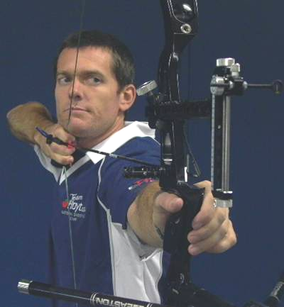
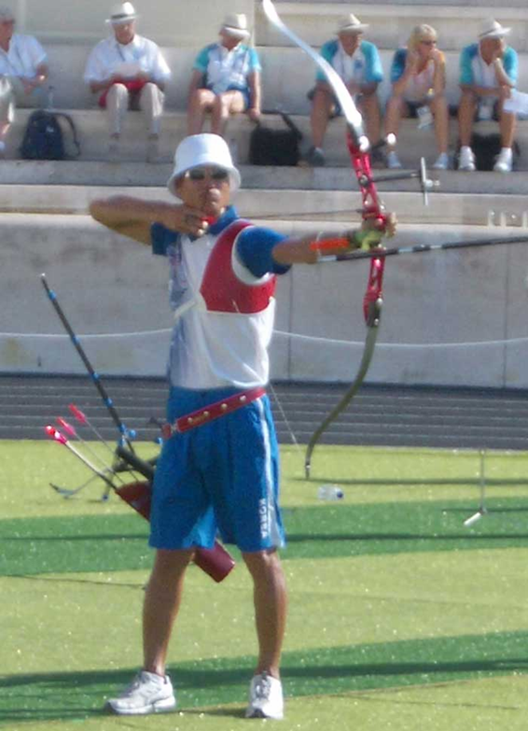
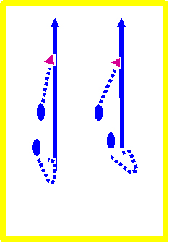
Correct
Incorrect

The shoulder blades should be aligned towards the bow hand creating a line to the right of the target for a right hand archer. Placing the shoulder blades with the line moving to the left is inefficient and will cause muscle fatigue and inconsistent shots.

Anchoring occurs when the scapula come to their final position along the back. The anchor point is the “touch point” for the drawing hand along the jaw line of the face (bone structure is solid). Additional touch points on the face include the chin, lips and nose. As each face is different, each archer should explore to find the best anchor point for them. The guiding principal is to adjust the equipment to the archer and not the archer to the equipment. In some cases a longer or shorter bow length may be required to achieve the correct string alignment.

Achieving anchor does not mean that everything stops moving. The movement slows down and becomes internal (invisible) rather than external (visible). It is very important to keep head and eyes steady and consistent throughout the draw and anchor. Archers and coaches should be especially vigilant to see that the head does not move as the string is drawn to the face. If head motion is detected, the archer and coach should explore alternative draw hand paths to anchor that will allow the archer to keep the head still. Also, acquiring a head position for the shot that allows the head to be in a more relaxed position facing the target, so that the archer does not have to look from the corner of the eye, helps in making the shot position stronger and more stabile.

The drawing arm elbow should be kept level with or only slightly above the line of the arrow or it will be difficult, if not impossible, to activate the correct muscles for completing the shot. It is very important to check the alignment of the draw arm with the arrow and bow hand. Avoid triangulation in either the vertical or horizontal plane as it weakens the shot and increases instability. A solid, bone-to-bone connection between the drawing hand (tab ledge) and the touch point on the face ensures a consistent nock to eye relationship.

III. The Execution of the Shot

The execution of the shot is divided into four steps: the transfer of force from the arms to the back, the loading of the back muscles and final positioning of the scapula and holding the energy of the bow; Aiming and expansion of the body by moving the bow arm scapula towards the target; Releasing the shot as a natural part of the follow-thorough.
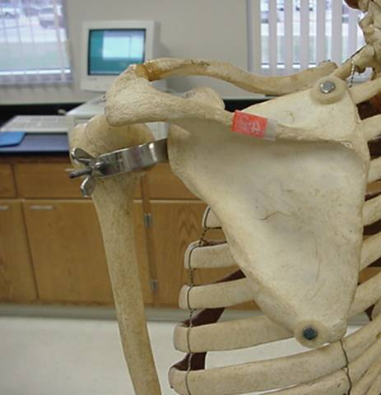
As the draw is being completed and the anchor point is being reached, a small amount of time is required for the draw load to be transferred onto the back muscles (lower trapezius). This is called the “holding” position. During the transfer to the holding position, focus on keeping the draw arm scapula down and moving the draw arm scapula towards the spine. There will be little external evidence of this transfer of power. Archers and coaches should check to see that the draw arm is straight and in line with the arrow and that the shoulder is down.

The execution phase of the shot is an “internal” activity that the archer can feel, but outside observes will not see. A coach who places his/her hand on the archers back near the lower trapezius (always with the archer’s permission) will feel tension, but may not always feel movement.

The draw side scapula moves down and towards the target.

Remember, too, that although the bow arm remains fully extended as if “reaching” toward the target, the archer does not “push” the bow arm forward. There is a very small amount of expansion needed to finish the shot. Often this final expansion can be achieved by holding/maintaining the necessary tension in the correct region of the back while feeling a sense of “relaxation” in the shoulders.

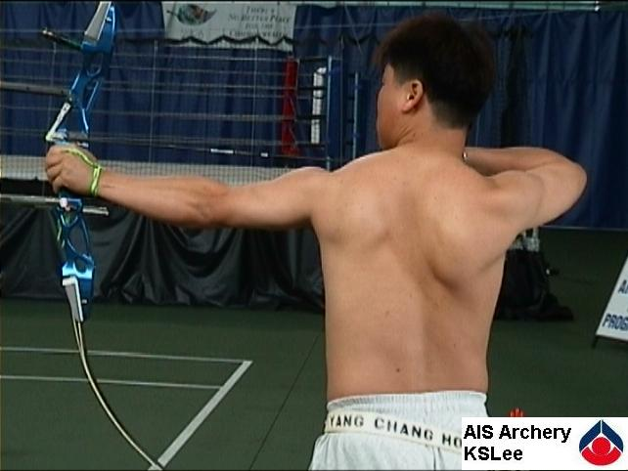
Remember that holding stage is not a step or a stopping point. It is part of a continuous process that allows the correct muscles to engage before aiming and expansion. Recurve archers should check their arrow position relative to the clicker during the final part of draw to anchor. By looking down at the arrow point, the archer can see when the clicker arm starts to move down the taper of the arrow point. A quick glance will tell the archer when the clicker is about to go off. It is recommended that clicker be set within 2 mm of the arrow point at the holding position.

Successful archers “feel” their shots more than aim them. The aiming and expansion phase of the shot sequence should be a very short interval of time and should be subconscious rather than conscious. The The bow arm shoulder is extended towards the target aiming must only start after the transfer and holding forming the acromial notch (arrow). phase is reached. Beginning to aim too early will distract the archer from the feel of the shot and reduce
consistency.

Aiming is a brief moment lasting not more than 1-3 seconds. Aiming is done subconsciously as the archer allows the pin to float around the center of the target. During the aiming phase the archer should de-emphasize aiming and focus on the internal process of the shot. Remain relaxed and let the sight move a bit rather than tighten up in an attempt to hold it still. Your brain will center the sight picture on the release.

The expansion and subsequent release must be initiated from the lower trapezius, not from pushing or pulling. The archer should feel the bow arm scapula move towards the target in a 2-3mm expansion of the draw. It is an internal movement of opening (relaxing) the chest and moving the bow arm scapula. At the same time, maintain or slightly increase the tension in the muscles that move the draw side scapula toward the spine.

The release is a natural byproduct of the follow through. During the release it is important to minimize tension in any place other than in the muscles that cause expansion. The bow arm should be strong and unmoving during the release and follow through process. As expansion activates the clicker, the release shortly follows. The natural recoil of the body causes expansion to continue and become visible again. Archers should sense or feel the clicker rather than listening for it to go off. An archer’s total mental focus must be on the muscles executing the expansion, not on the mechanics of the equipment.

Release the string by totally relaxing the drawing hand fingers and allowing the string to push the fingers aside. This is the phenomenon of letting the string go, rather than letting go of the string. Because the string fingers are relaxed, once the string clears, the fingers will return to a naturally curled, relaxed position, much like they were before the release. The path of the draw hand will follow closely along the neck. When done properly, a natural backward recoil action will occur.

The follow-through is the natural result of proper execution and the release of the bow pressure as restrained by the back muscles. Follow-through is simply a byproduct of good shooting technique. The response to the release of the shot will be the bow moving forward out of the bow hand (until stopped by the sling) and toward the target. The bow arm is held up stable and strong. The bow hand should be completely relaxed and fall downward naturally. The draw side scapula will move toward the spine and the drawing hand will recoil backwards and tend to go behind the neck. If the body alignment is correct, everything should initially move in the same plane or straight line towards or straight away from the target. The follow-through should be a natural reaction, not a cosmetic or exaggerated one. Archers and coaches can look at the follow-through as an indicator of how correctly the shot was executed.

IV. The Recovery

Relaxation and Feedback are the natural regenerative steps in repeating the shot sequence during an end. Once the shot is over and the arrow is in the target, it is time for relaxation and reflection on that shot. Archers should concentrate on how the shot felt and not on the specific results of the arrow placement. When a shot goes well, the archer will know it and when it doesn’t the archer will know where to improve. Relaxation is a brief amount of time and helps to prepare the archer for the next shot. Remember that relaxation is the key to long term consistency and accuracy. Relaxation is both fluid and dynamic. True power comes from relaxation, not tension. As the archer reflects on the previous shot they should dwell on, or reinforce, good shots and ignore (not reinforce) the bad shots. After the relaxation period, the shot sequence repeats itself.
Some additional thoughts: USA Archery is developing a DVD on the BEST method and it will be made available in the near future. Archers and coaches may want to pick up a copy of Total Archery by Kisik Lee. It is another good resource for explaining and supporting the BEST method.

The CDC is working on upgrades/revisions to the USA Archery Instructor/Coach Education System, and the accompanying manuals and materials, to accommodate the teaching of the BEST method principles in all certification courses. The National Archery in the Schools Program (NASP) materials will also incorporate the basic principles outlined above and is being endorsed by all the major U.S. archery organizations.

USA Archery adheres to the concept of having a standardized system of training archers, instructors and coaches and advocates a unified approach to employing such a system, so that there will be greater continuity among instructors/coaches along with less confusion and more success for the athletes.
VERY IMPORTANT! – The BEST method principles are best taught/learned, at first, with the use of training aids, such as a “string bow” or other rigid band (A ¾” wide luggage strap works very well. It’s adjustable, doesn’t stretch and fits comfortably into the fingers). Any archer trying to learn new technique can better accomplish the task when the stress/load of the bow is removed or greatly reduced and when the target faced is enlarged or removed. As the archer progresses and becomes more comfortable with these techniques, the load or degree of difficulty can gradually be increased, eventually to the full level that will be employed when shooting at a target face for score at competition distances.

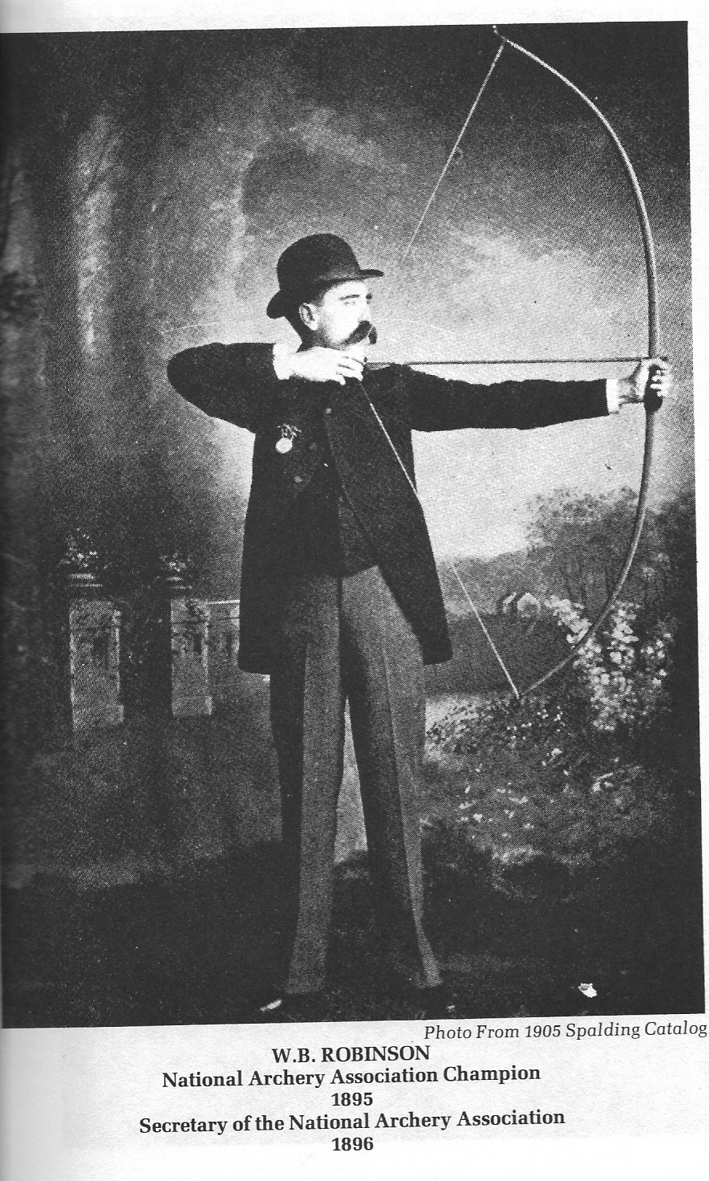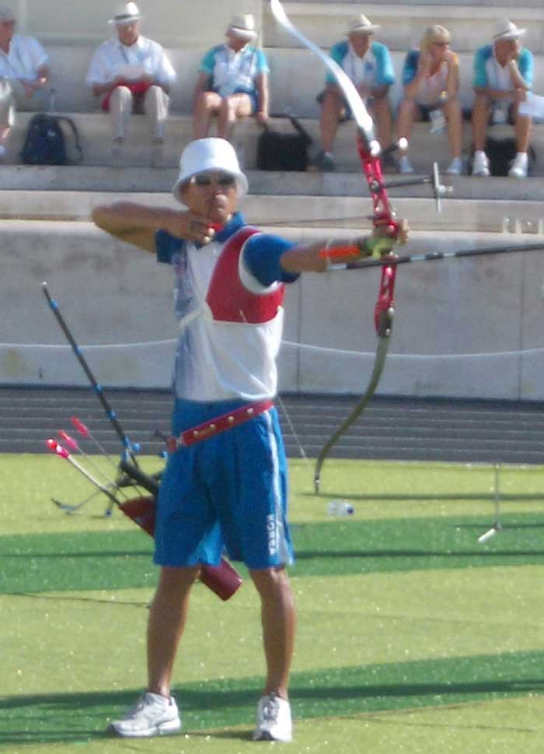

Take a look at these two photographs of archers from different eras. Notice how their shooting form is remarkably similar. Good shooting form is timeless. However shooting form is not, by itself, a quick and easy solution to achieving better scores and competitive success. There is no substitute for hard work. A good training plan that incorporates regular feedback from a good coach, good physical conditioning, proper nutrition and hydration and a comprehensive mental focus system are critical to success. The effective application of good biomechanics to your shot will help you to get the most out of your archery experience. You have to supply the desire and the effort to do what is necessary to obtain your goals.

.

The End Product of Good Form & Execution is a well-performed shot that the archer can easily repeat and that the archer feels confident in being able to perform under all conditions with positive results.

