Learn Archery 8-29-14; Coach Jefflyne Potter; USA Archery Level 3 NTS Coach
www.learnarchery.com
Badge requirements, we can address those in red ( for older scouts we add those * in black )
*1. Show that you understand the safety zones at an archery range.
*2. Know and follow the archery range whistle commands.
*3. Learn how to care for a bow and bowstring when in use and how to store them properly.
4. Learn about the different types of arrows and the kind of shooting for which they are used. Learn how to match arrows and bows and how to care for arrows.
*5. Demonstrate stringing and unstringing a bow or know three methods of stringing a bow.
6. Be able to explain the proper use of safety equipment, and other equipment used in archery.
7. Practice proper shooting techniques.
8. Be able to shoot an “end” of 5 arrows at a distance of 20 yards. Score your “end”. If you are already skilled at this distance, increase it. (20 yards is too much for a new archer-this would take time over several weeks newrequirements are for 20 feet-about 6 meters)
Connect:
1. Read about the history of archery. Trace the path of its development from a survival skill to a sport.
2. Speak with an NAA certified archery instructor. What is required to become an instructor? What is their role on the archery range?
3. Research possible career choices or volunteer positions that involve archery.
*4. What are the different types of bow? Know what “draw weight” means.
5. How can a bow’s length determine arrow speed and accuracy?
6. Learn to repair arrows and what the crest is for.
7. Know the names of the different parts of the bow and arrow
8.Know and understand 10 of the archery terms below.
Anchor Point
Bow Square
*Crest
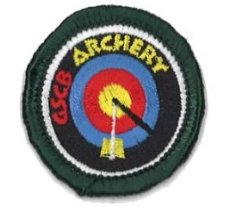
Draw
End
Eye Dominance
*Follow-through
Knocking the Arrow
Pulling Arrows
Release
Quiver
*Serving
Shooting Line
*Sight Window
Stance
String Height
Target Line
Torque
Trajectory
Waiting Line
for badge
http://www.girlscoutshop.com/s.nl/sc.15/.f?search=archery

